MODEL ENGINEERING COLLEGE, THRIKKAKARA

DEPARTMENT OF COMPUTER ENGINEERING



RECORD OF PRACTICAL WORKS

OOP CST205

CLASS: CS 3 B (2019 Ad.)

Name of Student: ADITHYA A

Roll No: 03

EXP No.: 01

OCCURANCE OF A CHARACTER

AIM

Java Program to find the frequency of a given character in a string.

PROGRAM

class Main{

static int Find_char(String str, char given_char)

{ int count=0;

for(int i=0;i<str.length();i++){

if(str.charAt(i)==given_char)

count++;

}

return count;

}

public static void main(String[] args)

{

String str = "test string test string";

char given_char = 't';

System.out.print("The number of occurances of "+ given_char + "in the string \" " + str + " \" is " + Find_char(str, given_char) );

}

}

OUTPUT

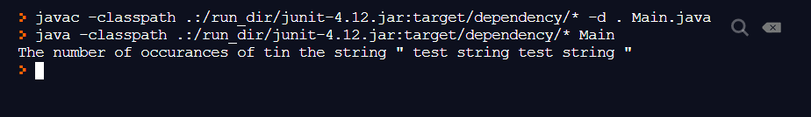

EXP No.: 02

REVERSING A STRING

AIM

Java Program to reverse a given string.

PROGRAM

class Main{

static StringBuilder Reverso(String str)

{ StringBuilder rev = new StringBuilder();

rev.append(str);

rev = rev.reverse();

return rev;

}

public static void main(String[] args)

{

String str = "test string test string";

System.out.print("The input string is \" "+ str +" \"\n");

System.out.print("The reversed string is \" "+ Reverso(str) +" \" \n");

}

}

OUTPUT

